Physical Education at Home
Keep Learning, Get Fit, Stay Motivated

Welcome to the Physical Education at home workbook.

Being at home doesn’t mean we have to stop all physical activity. Continuing with regular physical activity will not only improve your physical wellbeing, it’ll also improve your mental and emotional wellbeing.

Tasks set out in this workbook require very little equipment. Access to YouTube will be required to help with some of the tasks.

Why not get your family involved? Exercising with others other means you work harder and keeps you motivated – challenge each other!
Did you know: Physical activity has a huge potential to enhance our wellbeing. Even a short burst of 10 minutes' brisk exercise increases our mental alertness, energy and positive mood. Participation in regular physical activity can increase our self-esteem and can reduce stress and anxiety.

Physical Education at Home – Please complete the tasks below.

Each week you will be given a Fitness challenge to complete at home. You are asked to complete the challenge three times in a week.

Record your totals to keep track of your progression throughout the week. Seeing improvement can be really motivating.

At the end of your third session, input your scores into the class spreadsheet. Not only will this show you how you compare to your classmates, there will also be a competition between classes in your year group.

You may want to do some extra training sessions to improve your fitness levels and your scores over the next 8 weeks. At the end of this booklet, there are two training sessions, Beginners and Advanced training. Select a plan that suits your ability level and watch your fitness levels go through the roof.

Get your family involved to keep you motivated.

Week 1
Week 1 – Arms and Chest
How many can you do in 1 minute? | Monday | Wednesday | Friday Challenge
 | Total | Total | Total
Press-ups |  |  | Enter your Total onto class Spreadsheet
Triceps Dips |  |  | Enter your Total onto class Spreadsheet

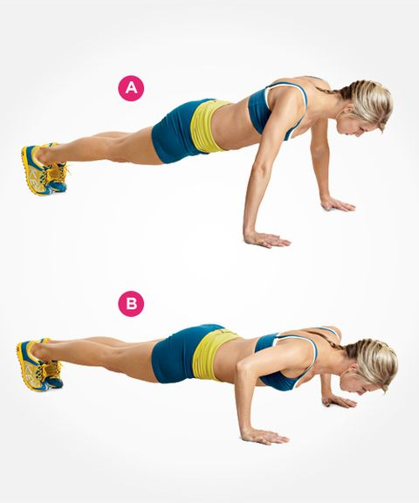
Press-ups
TECHNIQUE

Back straight, hips not lifted or sagging.

Keep your toes & heels together.

Hands at chest level, wider than shoulder width apart.

Eyes looking at the ground 3 feet in front of your head.

Go down until your chest is 1 inch off the ground.

Beginner push-up rhythm = down SLOW, up FAST.

Triceps Dips
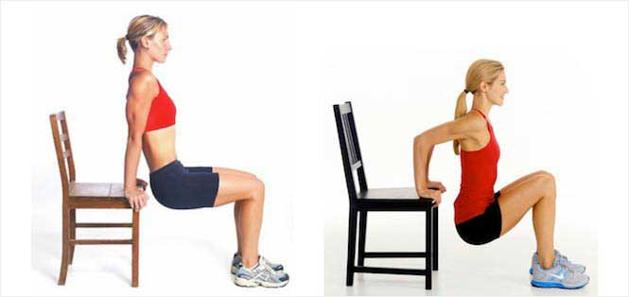
TECHNIQUE

Your hands should be shoulder-width apart on the surface you are dipping from, with your arms straight.

Start the move by bending your elbows. Dip down until your arms are at a 90-degree angle.

Extend your arms back to the starting position.
Week 2

Week 2 – Lower Body
How long without stopping? | Monday | Wednesday | Friday Challenge
 | Total | Total | Total
Squats |  |  | Enter your Total onto class Spreadsheet
Front Lunges |  |  | Enter your Total onto class Spreadsheet

Squats
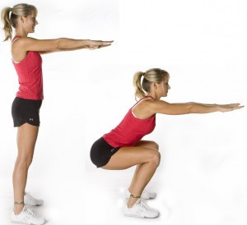
TECHNIQUE

Set your feet shoulder-width apart, toes slightly turned out.

Slowly bend at the knees and drop your hips to lower your body until knees are at 90 degrees.

At the bottom of the exercise pause for a moment and strongly push back up to the starting position.

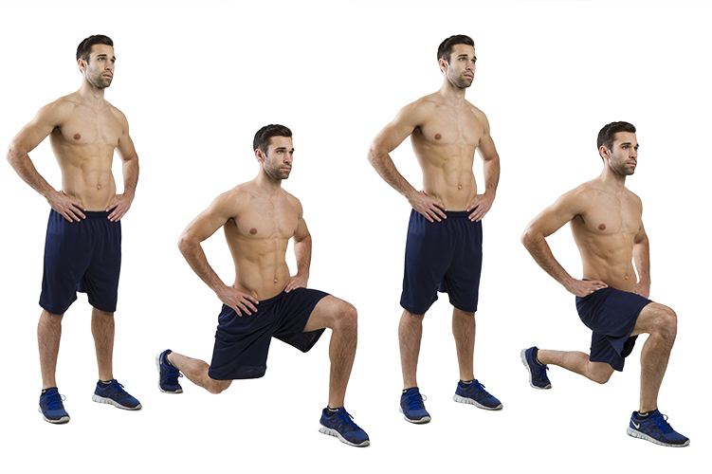
TECHNIQUE

Stand with your feet together, hands down and relax.
Step forward with your right leg into a lunge, slowly transferring your body weight onto your right (or front) foot.
With your back straight, continue lowering your body to a comfortable position.
Firmly push off with your front leg to return to start.
Repeat on left leg
Front Lunges
Week 3
Week 3 - Full Body
How many can you do in 2 minutes? | Monday | Wednesday | Friday Challenge
 | Total | Total | Total
Burpees |  |  | Enter your Total onto class Spreadsheet
High Knees |  |  | Enter your Total onto class Spreadsheet

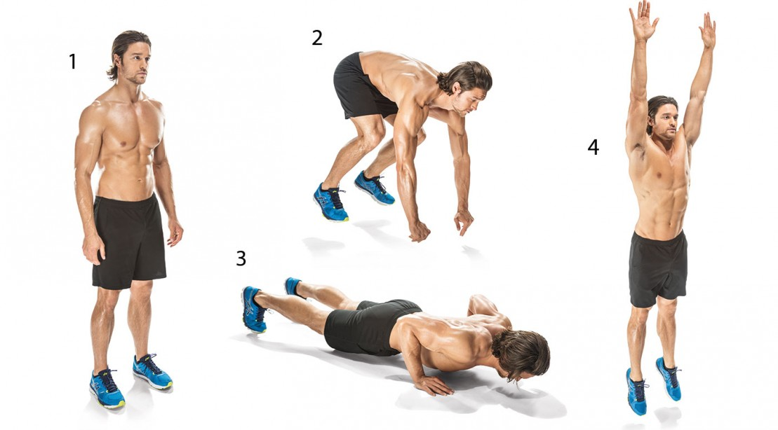
TECHNIQUE

Start from a standing position.
Squat down and place your hands on the floor in front of you.
Quickly kick both feet out behind you so you are in a press-up position
Do one Press-up.
Bring your legs forward to go into a squatting position.
Jump up.
Burpees
High Knees
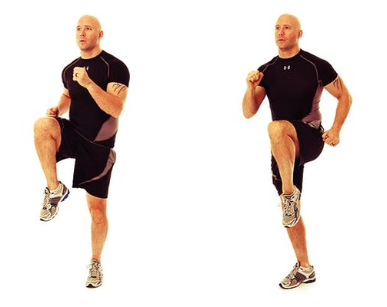
TECHNIQUE

Stand with your feet hip-width apart. Lift your left knee to your chest.

Switch to lift your right knee to your chest. Continue the movement, alternating legs and moving at a sprinting or running pace.
Week 4
Week 4 - Ab's
How many in the whole day? | Monday | Wednesday | Friday Challenge
 | Total | Total | Total
Leg Raises |  |  | Enter your Total onto class Spreadsheet
Ab Crunches |  |  | Enter your Total onto class Spreadsheet

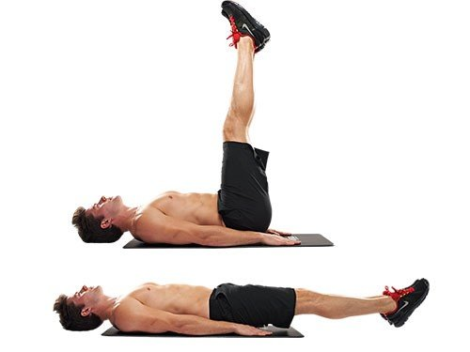
Leg Raises
TECHNIQUE
Lie on a mat on the floor, face up, legs extended.
Place your hands underneath your lower back and glutes so your pelvis is supported.
Begin to raise your legs toward the ceiling, pressing your thighs together and keeping the legs straight.
Lift until your hips are fully flexed and you can’t go any higher with straight legs, then lower back down
repeat.
Ab Crunches

TECHNIQUE
Lie down on your back.

Plant your feet on the floor, hip-width apart. Bend your knees and place your arms across your chest.

Contract your abs and inhale.

- Exhale and lift your upper body, keeping your head and neck relaxed.

Inhale and return to the starting position

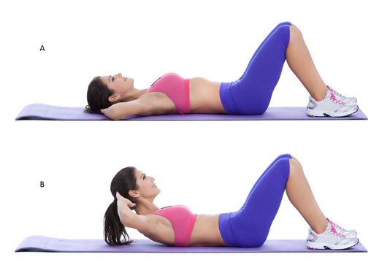

Week 5 - Arms
How many can you do in 1 minute? | Monday | Wednesday | Friday Challenge
 | Total | Total | Total
Walk Down Press up |  |  | Enter your Total onto class Spreadsheet
Shoulder Press |  |  | Enter your Total onto class Spreadsheet
Week 5

Walk Down Press-ups
TECHNIQUE
Start in a standing position

Place your hands on the ground as close to the feet as possible

Walk hands forward into a press up position

Perform a press-up

Walk hands back to starting position

Stand Up

Shoulder Press

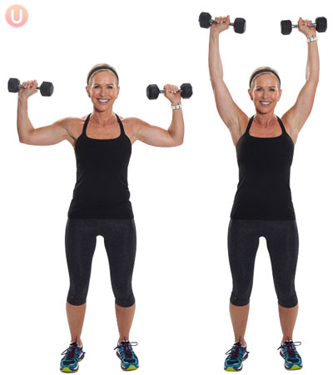

TECHNIQUE
Hold two tins of beans in each hand and sit on a chair with back support.

Plant your feet firmly on the floor about hip-width apart.

Bend your elbows and raise your upper arms to shoulder height so the tins are at ear level.

Pull your abdominals in so there is a slight gap between the small of your back and the bench.

Push the tins up and in until the ends of the tins touch lightly, directly over your head, and then lower the tins back to ear level.

Week 6
Week 6 - Legs
How long without stopping? | Monday | Wednesday | Friday Challenge
 | Total | Total | Total
Squat Jumps |  |  | Enter your Total onto class Spreadsheet
Lunge Jumps |  |  | Enter your Total onto class Spreadsheet

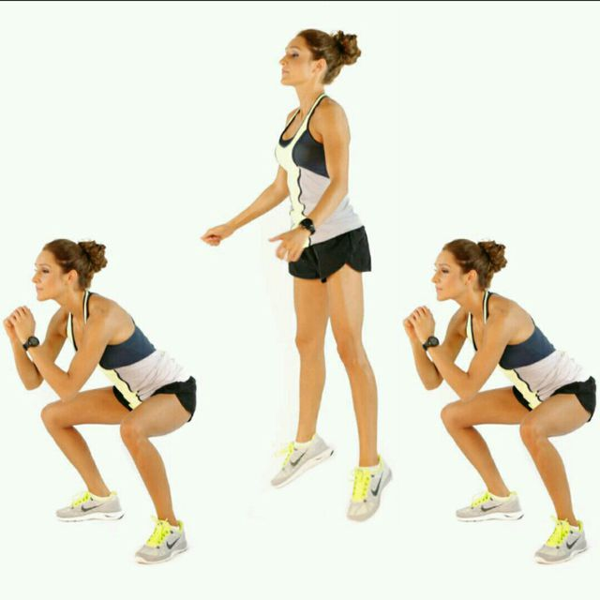
TECHNIQUE
Stand with your feet shoulder-width apart.

Start by doing a regular squat, then engage your core and jump up explosively.

When you land, lower your body back into the squat position to complete one rep. Land as quietly as possible, which requires control.

Squat Jumps
Lunge Jumps

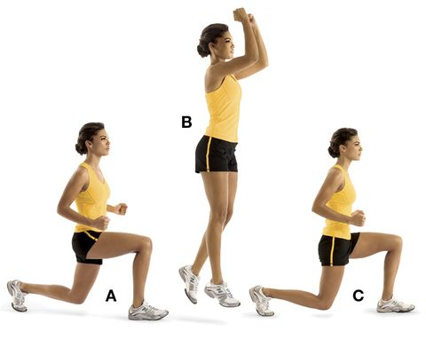
TECHNIQUE
Start standing with feet shoulder-width apart.
Jump your left leg forward and your right leg back into a lunge, with both knees at 90 degrees.
Jump up and switch your legs in mid-air so that you land in a lunge with your right leg in front.
Continue jumping back and forth, pausing as little as possible.

Week 7
Week 7 - Full Body
How many in the whole day? | Monday | Wednesday | Friday Challenge
 | Total | Total | Total
Star Jumps |  |  | Enter your Total onto class Spreadsheet
Squat Trusts |  |  | Enter your Total onto class Spreadsheet

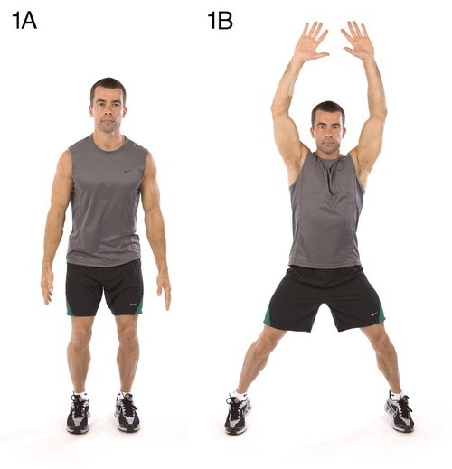
TECHNIQUE
To do a star jump, stand tall with your arms by your side and knees slightly bent.
Jump up, extending your arms and legs out into a star shape in the air.
Land softly, with your knees together and hands by your side. Keep your abs tight and back straight during the exercise.
Star Jumps
Squats Thrusts

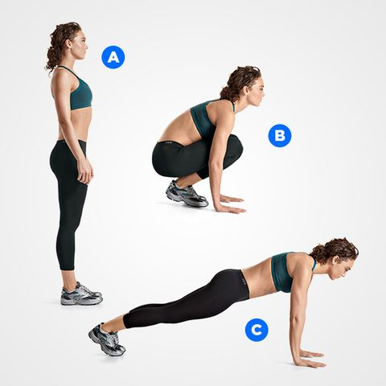

TECHNIQUE
Stand with your feet shoulder-width apart and your arms by your sides.

Lower into a squat position and place your hands on the floor.

Kick or step your legs back into a plank position.

Jump or step your legs forward to return to a squat position.

Return to the standing position.

Week 8 - Ab's
How many can you do in 2 minutes? | Monday | Wednesday | Friday Challenge
 | Total | Total | Total
Mountain Climbers |  |  | Enter your Total onto class Spreadsheet
The Plank (How long) |  |  | Enter your Total onto class Spreadsheet
Week 8

Mountain Climbers

TECHNIQUE
Get into a plank position, making sure to distribute your weight evenly between your hands and your toes.
Check your form—your hands should be about shoulder-width apart, back flat, abs engaged, and head in alignment.
Pull your right knee into your chest as far as you can.
Then switch, pulling that knee out and bringing the other knee in.
Keeping your hips down, run your knees in and out as far and as fast as you can.

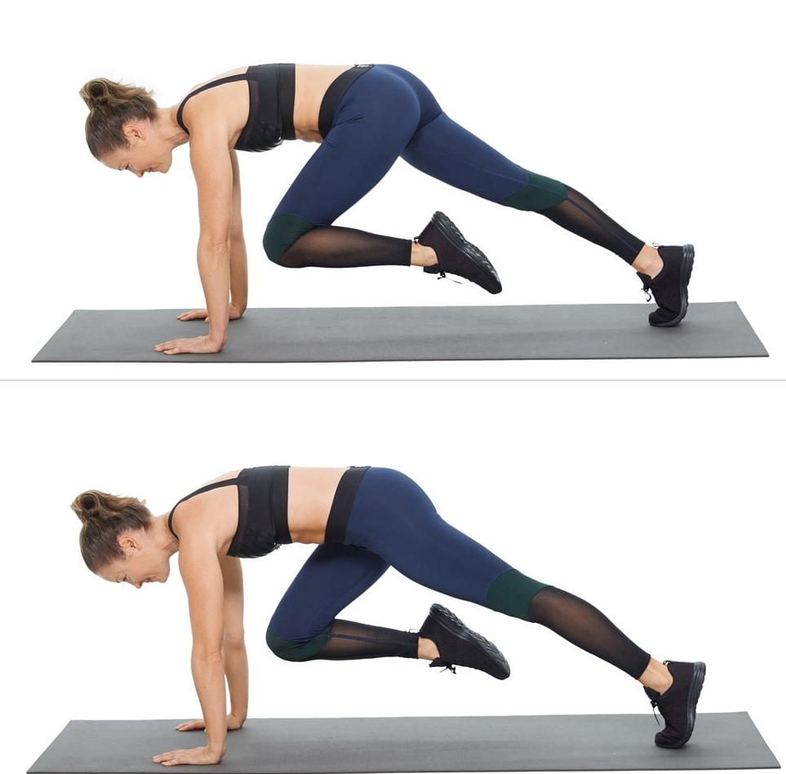

The Plank

TECHNIQUE
Plant elbows directly under shoulders (slightly wider than shoulder width).
Ground toes into the floor and squeeze glutes to stabilise your body. Your legs should be working, too.
Neutralize (keep straight) your neck and spine by looking at a spot on the floor about a foot beyond your hands. Your head should be in line with your back.
Hold the position for as long as you can.

Personal Development Programme
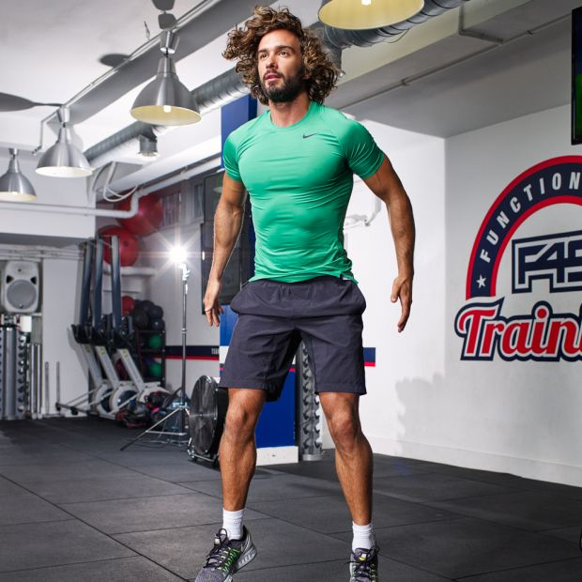
Improving performance doesn’t just happen on it own. In order to make progress, you must carry out a personal development programme (PDP)

As you will notice from the following training programmes, sessions will get progressively more challenging. This is to ensure your fitness levels continue to improve. Keeping sessions at the same level will only help you make progress to a certain level.

Select our beginner or advanced PDP depending on your ability. Complete two sessions a week on days of your choice. Type the names of each session into YouTube to find your workour.

It is important that you add in rest days between sessions to get the most out of each session. You may add sessions into the week if you are wanting to challenge yourself. Make sure you complete a warm-up (simple movements and stretches) before each session and make sure you hydrate before, during and after the session.

Beginners
Week 1 | Joe Wicks HIIT Home Workout for beginners + 5 Minute Abs | The Body Coach | Joe Wicks HIIT Home Workout for beginners + 5 Minute Abs | The Body Coach | Week 5 | 20 Minute Intense Fat Burner | Home HIIT | The Body Coach + 10 Minute Abs Blaster | The Body Coach | 20 Minute Intense Fat Burner | Home HIIT | The Body Coach + 10 Minute Abs Blaster | The Body Coach
Week 2 | 15 Minute Tabata-style HIIT | The Body Coach + 5 Minute Abs | The Body Coach | 15 Minute Tabata-style HIIT | The Body Coach + 5 Minute Abs | The Body Coach | Week 6 | Full Body Fat Burning Workout | 20 Minutes 20 Exercises | The Body Coach + 10 Minute Abs Blaster | The Body Coach | Full Body Fat Burning Workout | 20 Minutes 20 Exercises | The Body Coach + 10 Minute Abs Blaster | The Body Coach
Week 3 | 15 Minutes | 15 Exercises HIIT Workout | The Body Coach | Joe Wicks + 6 Minute Abs | The Body Coach | 15 Minutes | 15 Exercises HIIT Workout | The Body Coach | Joe Wicks + 6 Minute Abs | The Body Coach | Week 7 | 15 MINUTE ADVANCED HIIT WORKOUT | The Body Coach + 12 Minute Intense Cardio, Abs & Core Workout | The Body Coach | 15 MINUTE ADVANCED HIIT WORKOUT | The Body Coach + 12 Minute Intense Cardio, Abs & Core Workout | The Body Coach
Week 4 | 20 Minute Intense Fat Burner | Home HIIT | The Body Coach + 8 Minute Abs Workout | The Body Coach | 20 Minute Intense Fat Burner | Home HIIT | The Body Coach + 8 Minute Abs Workout | The Body Coach | Week 8 | 20 Minute Advanced Home Workout | Full Body Fat Burner | The Body Coach + 12 Minute Intense Cardio, Abs & Core Workout | The Body Coach | 20 Minute Advanced Home Workout | Full Body Fat Burner | The Body Coach + 12 Minute Intense Cardio, Abs & Core Workout | The Body Coach
Advanced
Week 1 | 20 Minute Advanced Fat Burning HIIT Workout | The Body Coach  https://youtu.be/kDvXi49_8wk | Cardio And Abs HIIT | Advanced Workout | The Body Coach  https://youtu.be/PxIkRgGxiG4 | Week 5 | 30 Minute Cardio & Abs Superset Workout | The Body Coach  https://youtu.be/xTxcVBiPyro | 30 MINUTE FULL BODY FAT BURNER | THE BODY COACH  https://youtu.be/cgi4OWzFAFc
Week 2 | 25 Minutes 25 Exercises | HIIT Challenge | The Body Coach  https://youtu.be/K4Xw0D5z7uc | 25 Minute Ladder HIIT Workout | Awesome Fat Burner You Can Do At Home  https://youtu.be/yhhiGHj_DmM | Week 6 | 30 Minute Cardio & Abs Superset Workout | The Body Coach  https://youtu.be/xTxcVBiPyro | 25 Minute Holiday Fat Burner | The Body https://youtu.be/kKUBdKahMHk Coach
Week 3 | The Burpee Challenge | 20 Minutes 20 Different Burpees | The Body Coach  https://youtu.be/H4ioyffaR6Y | 25 Minute Holiday Fat Burner | The Body https://youtu.be/kKUBdKahMHk Coach | Week 7 | 25 Minute FULL BODY Home HIIT Workout | The Body Coach TV https://www.youtube.com/watch?v=Hr-p7TikhPI | The Burpee Challenge | 20 Minutes 20 Different Burpees | The Body Coach  https://youtu.be/H4ioyffaR6Y
Week 4 | 30 Minute Cardio & Abs Superset Workout | The Body Coach  https://youtu.be/xTxcVBiPyro | 30 MINUTE FULL BODY FAT BURNER | THE BODY COACH  https://youtu.be/cgi4OWzFAFc | Week 8 | 30 MINUTE FULL BODY FAT BURNER | THE BODY COACH  https://youtu.be/cgi4OWzFAFc | 30 Minute Cardio & Abs Superset Workout | The Body Coach  https://youtu.be/xTxcVBiPyro

