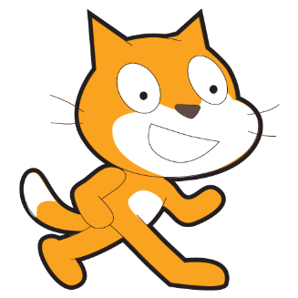
Scratch – Lesson 1
Name:

Questions to answer

Do you use left-click or right-click on a sprite to delete it?

Left-Click Right-Click

Which button will allow you to choose a sprite from file?

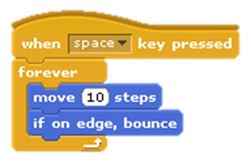
Which of these two pieces of code will keep the sprite moving until you tell it to stop?
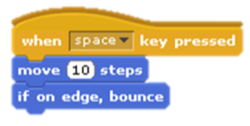

N | P | T | M | G | M | X | E | F | I
S | C | R | A | T | C | H | C | O | F
T | M | O | O | M | P | O | N | R | B
V | P | A | G | G | N | P | U | E | B
D | O | I | Q | T | R | C | O | V | Q
E | T | I | R | P | S | A | B | E | K
L | U | O | M | C | J | E | M | R | T
O | L | G | A | O | S | S | M | N | P
F | K | U | V | K | V | L | C | X | L
R | S | T | A | G | E | E | M | S | N
Words to find...

BOUNCE | CONTROL | FOREVER
MOVE | PROGRAM | SCRATCH
SCRIPT | SPRITE | STAGE

