**Cardio Respiratory Endurance**

**Cardio respiratory endurance** involves the ability of the heart and lungs to supply oxygen to the working muscle for an extended period of time.

It is also called **aerobic endurance** or **aerobic fitness**, it is the ability of the body to adjust to and recover from the effects of moderate to vigorous activity, such as running, swimming, or biking.

Improving aerobic endurance increases the ability of the heart, lungs, and muscles to do work over a longer period of time.

### The Aerobic Zone - 60% to 80%

Training in this zone will develop your cardiovascular system. The body's ability to transport oxygen to, and carbon dioxide away from, the working muscles can be developed and improved. As you become fitter and stronger from training in this zone it will be possible to train in game-related session at up to 75%, so getting the benefits of some fat burning and improved aerobic capacity.

### The Anaerobic Zone - 80% to 90%

Training in this zone will develop your lactic acid system. In this zone, your individual [**anaerobic threshold**](http://www.brianmac.co.uk/enduranc.htm#ant) is found - sometimes referred to the point of deflection (POD). During these heart rates, the amount of fat being utilised as the main source of energy is greatly reduced and glycogen stored in the muscle is predominantly used. One of the by-products of burning this glycogen is [**lactic acid**](http://www.brianmac.co.uk/lactic.htm). There is a point at which the body can no longer remove the lactic acid from the working muscles quickly enough. This is your anaerobic threshold or POD. Through the correct training, it is possible to delay the POD by being able to increase your ability to deal with the lactic acid for a longer period of time or by pushing the POD higher.

### The Red Line Zone 90% to 100%

Training in this zone is only be possible for short periods of time. This zone is achieved during **interval training** and only the very fit are able to train effectively within this zone. It also effectively trains your [**fast twitch muscle fibres**](http://www.brianmac.co.uk/muscle.htm) and helps to develop speed.

AGE

|  |  |  |  |  |  |
| --- | --- | --- | --- | --- | --- |
| **Colour** | **Level** | **MEPS** | **Description** | **Beats Per Minute (BPM)** | **What does it look like?** |
| RED | 100% | 4 | 100% pace  10s sprint | > 204 | Unable to talk. Completely out of breath. Feels impossible to keep going. |
| RED | 90%-100% | 4 | 90% pace Anaerobic Training Zone  30s – 3min of work | 184-204 | Can speak one word at a time. Breathing very hard. Wondering how long you can work at this pace for. |
| YELLOW | 80%-89% | 4 | 80% pace  Anaerobic Training Zone | 163-182 | One or two sentences that require more effort. Almost feels uncomfortable. |
| GREEN | 70%-79% | 3 | 70% pace  Aerobic Training Zone | 143-161 | Can have a short conversation but require more effort. |
| BLUE | 60%-69% | 2 | 60% pace  Aerobic Training Zone | 122-141 | Easy to have a conversation. Feels like you can maintain this pace for a prolonged period of time. |
| GREY | 50%-59% | 1 | Jog - Active Recovery | 102-120 | Effortless conversation. Feels like you can maintain this pace for hours. |

**Maximum Estimated Heart Rate**

Your Maximum Heart Rate is estimated from the formula 211- 0.64 x age. You can then use a heart rate monitor or take your pulse for 6 seconds and x10 to track your heart rate during your exercise session. To ensure your zones are correct it is important that your zones match your actual effort.

See below for an example of my (Mr Rizza) Estimated Maximum Heart Rate and training zones. So how old am I?

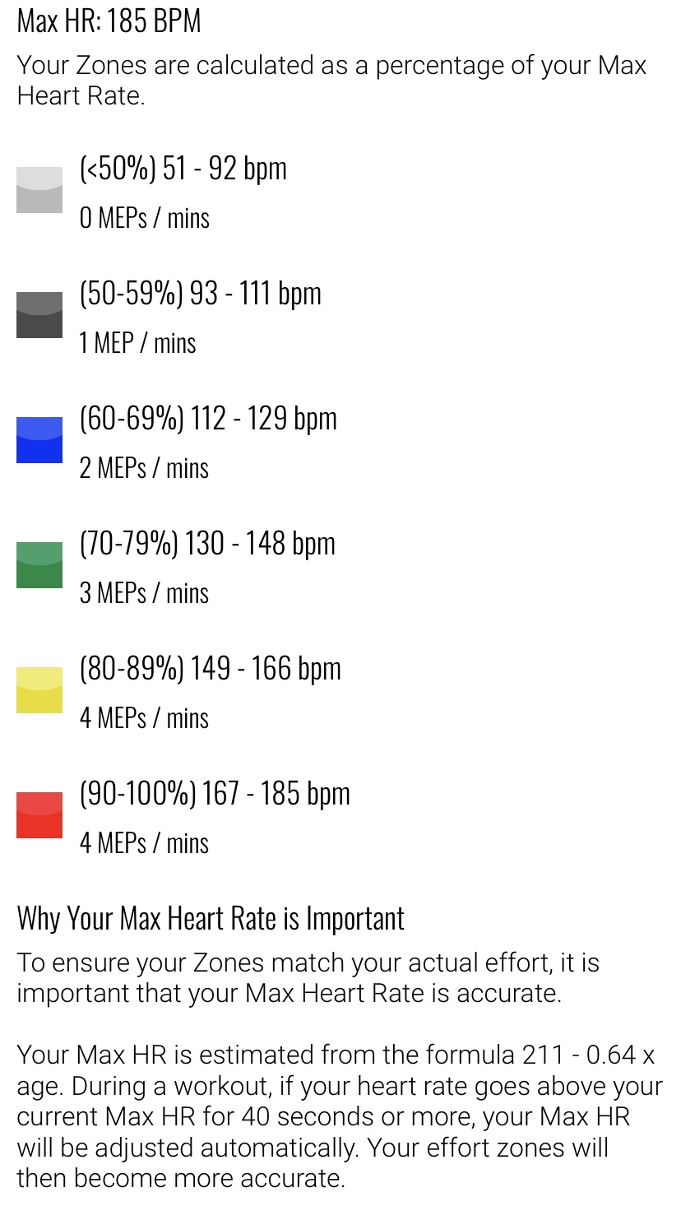

|  |  |  |  |  |  |
| --- | --- | --- | --- | --- | --- |
| **Colour** | **Level** | **Beats Per Minute (BPM)** | **MEPS Awarded Per Minute In Effort Zone** | **Number of minutes in Zone during exercise session** | **MEPS in Effort Zone x Number of Minutes in Zone** |
| RED | 100% | > 204 | 4 |  |  |
| RED | 90%-100% | 184-204 | 4 |  |  |
| YELLOW | 80%-89% | 163-182 | 4 |  |  |
| GREEN | 70%-79% | 143-161 | 3 |  |  |
| BLUE | 60%-69% | 122-141 | 2 |  |  |
| GREY | 50%-59% | 102-120 | 1 |  |  |
| **Total Numbers MEPS Achieved in session** | | | | |  |

**How often should we be in the RED zone?**

The World Health Organization & American College of Sports Medicine recommend that adults perform >150 minutes of moderate-intensity (BLUE & GREEN zone) OR 75 minutes of vigorous-intensity (YELLOW & RED zone) cardiorespiratory activity per week (or a combination of the two).  So, if you are spending ~30 minutes in the YELLOW and RED zones three days a week or ~20 minutes four days a week, you will meet the minimum recommended guidelines for a healthy lifestyle.

If you have fitness or performance goals that extend beyond general health and well-being, you may spend more time in the RED zone to take yourself to another level.

RED zone workouts should be very challenging, and they should tax your body.  In fact, that’s the point – we overload our body so that we can see adaptations.  Whenever we overload our body, it is important that we give it time to rest and recovery so that it can make the necessary adaptations before we overload it again.  If we do not offer enough time for recovery, we experience diminished returns and are at risk of over-training and injury.

Give yourself at least 24 hours between RED zone workouts, and if you are newer to exercise, give yourself at least 48 hours.  We also recommend alternating your YELLOW and RED zone days with BLUE and GREEN zone days to offer your body and mind a little more recovery.  It is better to gradually progress in a way that allows you to sustain your healthy lifestyle than to blow out after a few weeks.  Be sure to listen to your body and take rest when you need it.   Consult a fitness professional if you are not sure how to effectively use the RED zone to achieve your goals.

**Daily Challenge (Beat Mr Rizza)**

