**St Thomas of Aquin’s RC High School**



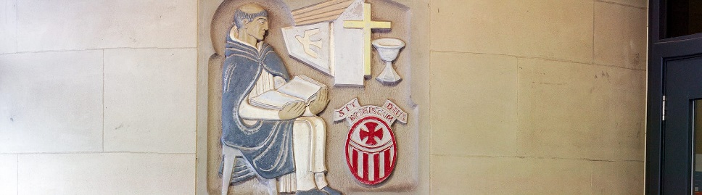

**St Thomas of Aquin’s RC High School Better relationship, Better learning, Better behaviour Policy – June 2019**

St Thomas of Aquin’s Roman Catholic High School is a learning community which ensures a safe, supportive and enjoyable environment where pupils, staff, and parents are inspired and motivated to work hard for one another to fulfil pupils’ God-given potential.

**S**elf-Discipline

**T**eamwork

**T**rust

**H**igh expectations

**O**penness

**M**utual Respect

**A**chieving excellence

**S**uccess

**Policy commenced on June 2019**

**Policy to be updated on June 2022**

**Nominated lead: Christopher Santini**

**THE POLICY**

1. **POLICY STATEMENT**

This policy is based on the City of Edinburgh Council’s policy and views of staff, parents and pupils of the school. It aims to support children’s emotional and social development, recognising that education is an integrated and important part of the holistic development of children. Implementation of the policy should help to establish and maintain mutual respect and better relationships. The resulting better behaviour enables better learning and better holistic development.

1. **SCOPE**

All staff in our school are covered by this policy. This includes office staff and service support staff.

1. **POLICY CONTENT**

Every child and young person has the right to a high quality education. Positive relationship and behaviour in all aspects of school life are fundamental to enable effective teaching and learning to take place. The school has adopted the aforementioned visions and values to create a caring learning environment as well as the following key principles:

• Strong leadership in promoting positive relationships at all levels and a culture and ethos of positive relationships

• Positive relationships and constructive communication between staff and children including using active and empathetic listening

• Children and Young People’s rights are embedded into the systems, culture and practices of the school

• Modelling respectful relationships and behaviour

• The development of personal and social skills in children and young people to ensure their own wellbeing and that of others

• Opportunities for children and young people to develop an understanding of their rights and responsibilities

• Staged interventions and Nurturing approaches

• Curricula focus on social and emotional well being

• Continued Learning and Professional Development opportunities linked to the General Teaching Council of Scotland standards

• Links to other policies e.g. Preventing and Responding to Incidents of Bullying and Prejudice

1. **IMPLEMENTATION**

This policy should be read in conjunction with the Better Relationships, Better Learning, Better Behaviour (BRBLBB) Staged Intervention Teacher Support Document as well as the ‘Behaviour is for Learning’ in the Classroom Document, which describes the measures to support this policy. Please see appendices.

1. **ROLES AND RESPONSBILITIES**

The head teacher has overall responsibility for ensuring the effective implementation of this policy. In particular, the head teacher ensures that the concerns of pupils are elicited, listened to, and appropriately addressed and that the provisions of “Getting it Right for Every Child” are taken into account when working in partnership with children, families, and other professionals on issues of communication and behaviour.

All staff are responsible for ensuring that the policy and procedures are followed. This includes using the range of approaches detailed in the Staged Intervention document and Behaviour is for Learning in the Classroom document.

Parents and carers are regarded by the school as key partners who are asked to work in partnership with the school to develop, implement and evaluate these policy procedures. Parents are expected to assist in maintaining positive relationships and high standards of behaviour and are invited to discuss any related concerns with the school.

Pupils are expected to take responsibility for their own behaviour on or off the school site and will be made fully aware of the school policy, procedure, and expectations. Pupils also have a responsibility to ensure that incidents of disruption, violence and bullying and any form of harassment are reported.

1. **RELATED DOCUMENTS**

* Standards in Scotland’s Schools etc. Act (2000)
* Additional Support for Learning Act (2004) – amended 2009
* Parental Involvement Act 2006
* The Equality Act 2010
* UN Convention of the Rights of the Child
* Children and Young People Act 2014
* BRBLBB Classroom Cylinder Poster
* BRBLBB teacher Staged Intervention Support Document
* BRBLBB Restorative Conversation Support Document -‘Getting Back on Track’
* BRBLBB ‘Getting Back on Track’ Pupil Monitoring Booklet

1. **EQUALITIES AND RIGHTS IMPACT, SUSTAINABILITY IMPACT AND RISK ASSESSMENT**

St Thomas of Aquin’s RC High School is committed in our duty to eliminate discrimination, victimisation and harassment, advance equality of opportunity and foster good relations. We will make reasonable adjustments wherever appropriate for those individuals with “protected characteristics” and of particular relevance, disability; gender reassignment; race; religion or belief; sex or sexual orientation; pregnancy and maternity.

1. **REVIEW**

This policy will be communicated in draft and final form to all stakeholders via school email and Parent Council. It will also be available for staff on the school server. In addition, a draft will be given to the Pupil Council for feedback and amendments. This policy will be reviewed on a 3 yearly basis with the BRBLBB Working Party, based on pupil, staff and parental feedback.

**Appendix**

* BRBLBB ‘Behaviour is for Learning’ in the Classroom Document
* BRBLBB Staged Intervention Teacher Support Document
* BRBLBB Restorative Conversation Support Document -‘Getting Back on Track’
* BRBLBB ‘Getting Back on Track’ Pupil Monitoring Booklet

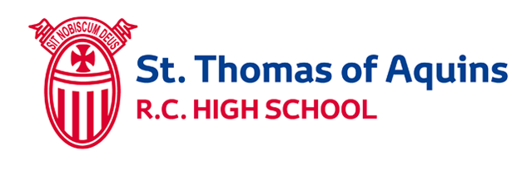

***‘Behaviour is for Learning’ in the classroom***

**I am:**

Producing a piece of work which I am proud of

Working well with my peers

Being Respectful of others

Listening to instructions given

On time for class

Prepared to learn

**I am:**

Not producing my best work

Distracting others in class

Not listening to instructions given

Late to class

Not prepared to learn

**I am:**

Being disruptive

Not listening to instructions given

Not producing any work in class

Being disrespectful to my peers and teacher

Often late to class

Often not prepared to learn



**I can be rewarded with:**

Verbal Recognition

Merits

Postcards

Certificates

Subject Award

**Action by Teacher can include:**

Verbal Warning

Move seat

Time Out

Classroom Detentions

Out of Class Timetable

**Action by Curricular leader can include:**

Out of class

timetable

Departmental/ behaviour booklets

Faculty Detentions

**St. Thomas of Aquin’s RC High School**

***Better relationships, Better Learning, Better Behaviour***

***Staged Intervention Teacher Support Document***

|  |  |  |  |  |  |
| --- | --- | --- | --- | --- | --- |
| **Pathways** | **Who** | **Behaviour/behaviours on Display** | **Actions** | **Refer to** | **Next Steps could include:** |
| Positive Pathway | All staff, Classroom teacher, CL, SLT, PSL | Pupils producing work of a good standard, pupils working to the best of their ability, cooperating well with peers, being respectful of others and  listening to instructions given | Pupils can be rewarded with: verbal praise, merits, postcards, certificates or Subject Award | Inform CL, PSL,SLT, HT and Parents | Recognising and reinforcing effort during the lesson.  If pupils are continuously working to their best ability teachers can inform parents of this. Use of departmental/ whole school reward system. |
| Pathway 1 | Classroom teacher | Expected standards of behaviour are not met (i.e. not listening to reminders, low-level disruptive behaviour).  If challenging behaviour persists | Verbal warning (max 2); move seats; short conversation outside classroom; teacher detentions and out of class timetable. | Pink referral form to be completed and issued to CL for action at Pathway 2. | Restorative conversation with teacher and pupil led by CL; departmental monitoring booklet issued; reflective apology and departmental detentions. |
| Pathway 2 | Curriculum Leader | Ongoing refusal to work with classroom teacher, refusal to move seat or leave room when instructed by teacher, confrontational behaviour, persistent challenging behaviours  If challenging behaviour persists | Departmental hosting arrangements for an agreed period of time; departmental monitoring booklets with letters sent home/PSLs copied outlining targets and timing; departmental detentions;  Guidance sought from PSLs/ SfL Leader and  restorative meeting between CL/ Pupil. | Yellow referral form  Completed by CL and issued to SLT for action at Pathway 3.  Notification to parents via standardised letter.  Notification to PSLs via yellow referral form. | Restorative conversation with CL and pupil led by SLT; PSL/SLT monitoring booklet issued; reflective apology and central detentions. |
| Pathway 3 | SLT/PSL | On-going confrontational/disruptive behaviour in class;  poor attitude to learning /challenging behaviour; and refusal to follow CL’s instruction.  Limited impact of action undertaken at departmental level.  Serious one off incidents (i.e. swearing at member of staff/ racist comment) | Parental interview and central detention; on-call; removed by SLT/ on-call staff; accommodated out of class for up to 48 hours with liaison with CL regarding return arrangements  parental interview;  central detention;  restorative conversation between CL /pupil prior to return; discussion at Team Around the Cluster meetings and  referral to partner agencies  *Please see rationale for use of on-call rota on the school server. | Incident recorded on yellow referral form by CL for action by SLT with support from  PSLs/ SfL leader (investigation and collation of classwork from CLs to be completed during period of isolation). | Matter will be acknowledged and investigated promptly with a view to a full resolution within 5 days including feedback to teachers/CLs involved via yellow referral form.  Restorative conversation between CL/ Pupil led by SLT;  PSL/ SLT monitoring booklet with letter home to parents; parental interview; pupil profile completed by Integrated Support Team. |
| Pathway 4 | HT  Supported by SLT, PSLs, SfL, CLs and  CEC | Fighting; weapons; violence and extreme circumstances. | On-call; pupil removed by SLT/ on-call staff and  parental interview.  In extreme circumstances,  alternative to exclusion;  exclusion and  hosting if appropriate. | SLT/ PSL support (investigation and organisation of classwork during period of isolation)  and referral to partner agencies. | Reintegration to school.  SMT monitoring booklet.  Support plan. |



How were you feeling at the time?

**Name:** ______________________

**Date:** _______________________

Who has been affected by what happened and how?

What impact has this had on the learning of other pupils?

What can you do now to get things back on track?

How could you do things differently next time?

How do you feel about it now?

**What happened?**

**Student** ________________________________________

**Teacher**________________________________________

**Parent**_________________________________________

Next Steps

*Getting back on track*

R.C. High School



**St Thomas of Aquin’s**