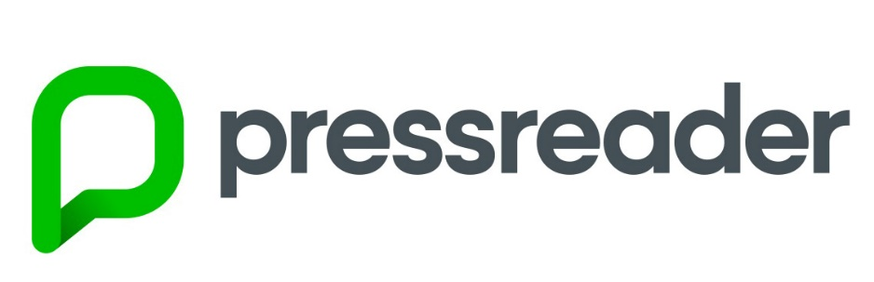

**PressReader** - it is a digital newspaper, which gives you unlimited access to thousands of magazines and newspapers from around the world and in other languages. It has over 6000 worldwide newspapers and magazines including over 100 UK & Irish newspapers and  300 UK magazines; publications from over 100 countries in 60 languages. We can download 20 titles a day.

The schools IP address acts as a hotspot, we do not need to register for a public library card to browse the titles and we can read titles online, either in a browser or via the App.

However If we wish to download for offline access or to access at home, we would then need to register with public libraries to access PressReader. You can find out more information here <https://yourlibrary.edinburgh.gov.uk/web/arena/pressreader> .

In the school we can access PressReader directly from google.

Please note PressReader is currently not working with Internet Explorer browser but it works with Google Chrome and with Mozilla Firefox.

You should see the option to click on publications or see the choice of publications straight away when you open PressReader. The search box is also available.

You can see how to access PressReader catalogue/publications if you are connecting directly from google and the catalogue/publication options are not visible:

**Click on the top left corner to open the menu and then click on Publications as shown below:**

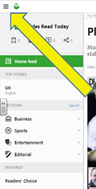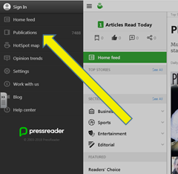

**You will be then taken to the catalogue/publications page where you can search by country, titles, etc (see below):**

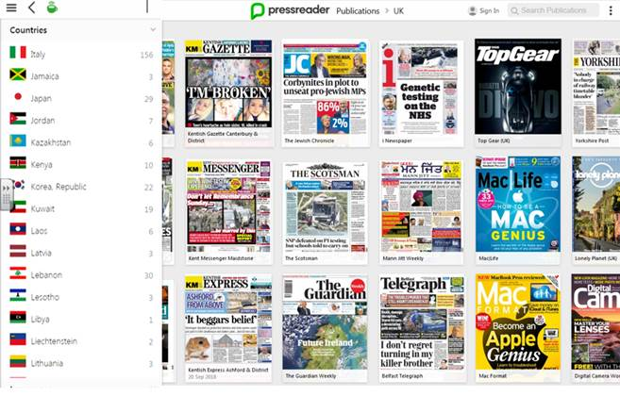



The Day is an online website with valuable education news resources. It has news articles which have been adapted for pupils to make them understandable. Access is at home and school.

It can be mainly used by English, Modern Languages, Modern Studies, PSE, Science and Religious Education departments but it really is a whole school resources for all year groups.

You also get articles translated into other languages and you are provided with tasks, ideas and suggestions. The content of the site is very good, it is up to date with valuable links.

Please note, this is a website you can only access limited number of articles for free or sign up for a free trial.

For more information check the website <https://theday.co.uk/> or speak to school librarians.