Films based on books released in recent years
for children and young adults

“The Knife of Never Letting Go” by Patrick Ness (2021)*
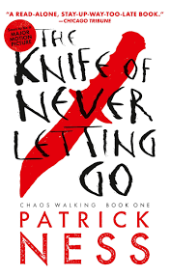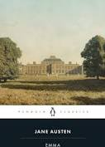
“Emma” by Jane Austen (2020)*
“David Copperfield” by Charles Dickens (2020)*
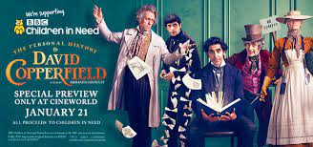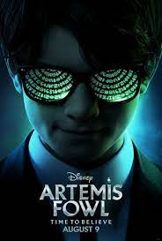
“Artemis Fowl” by Eoin Colfer (2020)*
“High Fidelity” by Nick Hornby (2020)*
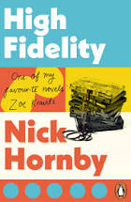 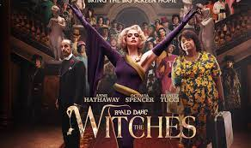 “ The Witches” by Roald Dahl (2020)*

‘’The Sun is Also a Star” by Nicola Yoon (2019)*
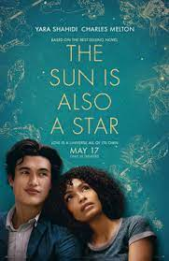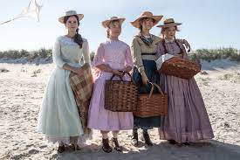
“Little Women” by Louisa May Alcott (2019)*

“The Watchmen ” by Alan Moore : comic books (2019)*
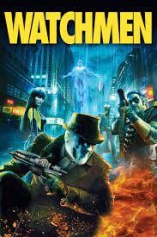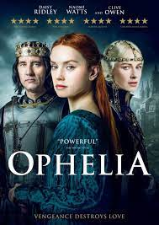
“Ophelia” based on William Shakespeare “Hamlet” and ‘’Ophelia’’by Lisa Klein (2019)

*Titles available in school library

