S3 Home Study Task 2

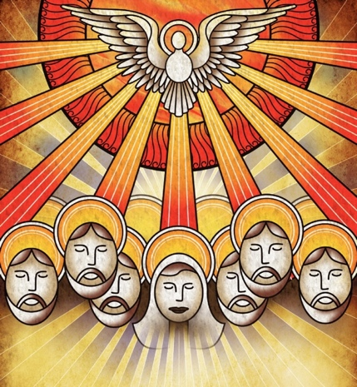

Week beginning Mon 18 May 2020
Due: Friday 29 May 2020
Topic: Pentecost

 | Pentecost  Holy Spirit  (Videos – click links) | 10 mins
 | Read about the events of Pentecost here.  Do some research on the internet about Pentecost and how it is celebrated around the world. (The Feast of Pentecost this year is on 31st May) | 30 mins
 | Create your own presentation on Pentecost Explain what Christians believe about Pentecost and the Holy Spirit. How is this feast celebrated? You could also explore how this event is portrayed through art and music. | 30-40 mins

Thursday 21st May is the Feast of the Ascension. Normally at school we would have Mass to celebrate this feast in the Sacred Heart Church. You can watch a short video about the Ascension by clicking on this link. You can also watch a live-streamed Mass from St Mary’s Cathedral every day here.

