S2 Home Study Task 2

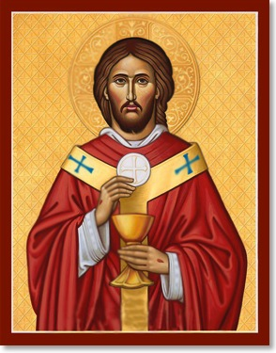

Week beginning Mon 18 May 2020
Due: Friday 29 May 2020
Topic: The Eucharist

 | Sophia SketchPad: The Eucharist  (Video – click link) | 8 mins
 | Miracles of the Eucharist  (Website – click link and read about three or four stories) | 20 mins
 | Create your own presentation on The Eucharist. Explain what Catholics believe about the Eucharist and why the Mass is so important. You can also mention some miracles of the Eucharist from the website above. | 30-40 mins

Thursday 21st May is the Feast of the Ascension. Normally at school we would have Mass to celebrate this feast in the Sacred Heart Church. You can watch a short video about the Ascension by clicking on this link. You can also watch a live-streamed Mass from St Mary’s Cathedral every day here.

