S2 & 3

The Case for Christ:
Did Jesus Rise from the Dead?

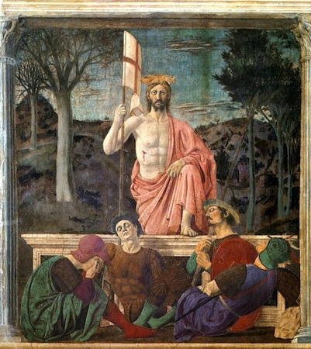

Deadline: Friday 8th May 2020
Submit to your RE teacher on MS Teams

I have examined key events in the New Testament where God is revealed as Father, Son and Holy Spirit. I have considered how this affects my understanding of the nature of God. RERC 3-04a / RERC 4-04a (Revealed Truth of God)

I have reflected upon the centrality and significance of the death and resurrection of Jesus to the Christian understanding of Jesus as Son of God and Son of Man. I can describe how this has affected my own and others’ understanding of and belief in Jesus. RERC 4-07a (Son of God)

Task Instructions:

- Read The Gospel of Mark Chapters 14-16, which tells the story of the Death and Resurrection of Jesus. If you don’t have a Bible at home, you can read it online by clicking the link on the text above. You should note down any significant details in your notebook. (Estimated time: 30-45 minutes)
- Watch this video: What Romans said about crucifixion. Make notes. (Estimated time: 10 minutes)
- Do some independent research on the historical sites and artefacts associated with the death and resurrection of Jesus. Focus especially on the Church of the Holy Sepulchre in Jerusalem and the Shroud of Turin. Make notes. (Estimated time: 30-45 minutes)
- Watch this video: Did Jesus rise from the dead? Part One: The Facts. Make notes. (Estimated time: 10 minutes)
- Watch this video: Did Jesus rise from the dead? Part Two: The Explanation. Make notes. (Estimated time: 10 minutes)

- Write an essay entitled The Case for Christ: Did Jesus rise from the dead? Your essay should be at least 800 words long, and you can use the sections above as a structure. If you need any help doing this task, you can contact your teacher on Microsoft Teams. (Estimated time: 2-3 hours)

The Case for Christ: Marking Grid
Maximum Mark: 20

Knowledge and Understanding (Maximum 12 marks)

10-12 | 7-9 | 4-6 | 2-3 | 0-1
There is clear evidence that the candidate has drawn together relevant and accurate content from a range of sources. | There is evidence that the candidate has drawn together mostly relevant and accurate content from some specific sources. | There is some evidence that the candidate has drawn together relevant and/or accurate content, but use of sources tends to be general and limited. | There is limited evidence of relevant and/or accurate content, and use of sources is limited. | There is little evidence of relevant and/or accurate content, but references to sources are brief and undeveloped.
Knowledge and understanding is consistently detailed/developed, accurate and relevant. | Knowledge and understanding is mostly detailed/ developed, accurate and relevant. | Knowledge and understanding has some detail/depth and is accurate and relevant. | Knowledge and understanding has limited depth and is sometimes inaccurate and/or irrelevant. | An attempt at knowledge and understanding, but lacks depth and is inaccurate and irrelevant.

Analysis and Evaluation (Maximum 8 marks)

7-8 | 5-6 | 3-4 | 0-2
The candidate clearly understands the arguments and their strengths/weaknesses, and uses them to reach a reasoned conclusion. | The candidate understands the arguments, but analysis and evaluation could be developed further e.g. by looking at strengths and weaknesses. | The candidate shows limited evidence of the ability to analyse and evaluate arguments and their strengths/weaknesses. | The candidate shows little or no evidence of engagement with the strengths and weaknesses of the arguments.

