S1 Home Study Task 2

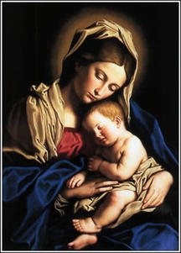

Week beginning Mon 18 May 2020
Due: Friday 29th May 2020
Topic: Mary

 | Why Catholics Call Mary Their Mother  (Video – click link) | 10 mins
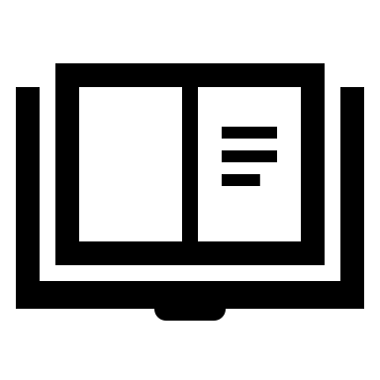 | “Mary, Our Mother”  (PowerPoint Presentation – click link) | 10 mins
 | Create your own presentation or write an essay on Mary. Explain what we know about we know about her from the Bible and the teachings of the Church. Try to find out how Catholics honour Mary e.g. the Rosary, pilgrimages etc. Look up some art and music which portrays Mary. | 20-30 mins

Thursday 21st May is the Feast of the Ascension. Normally at school we would have Mass to celebrate this feast in the Sacred Heart Church. You can watch a short video about the Ascension by clicking on this link. You can also watch a live-streamed Mass from St Mary’s Cathedral every day here.

