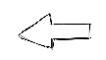  FINISH | 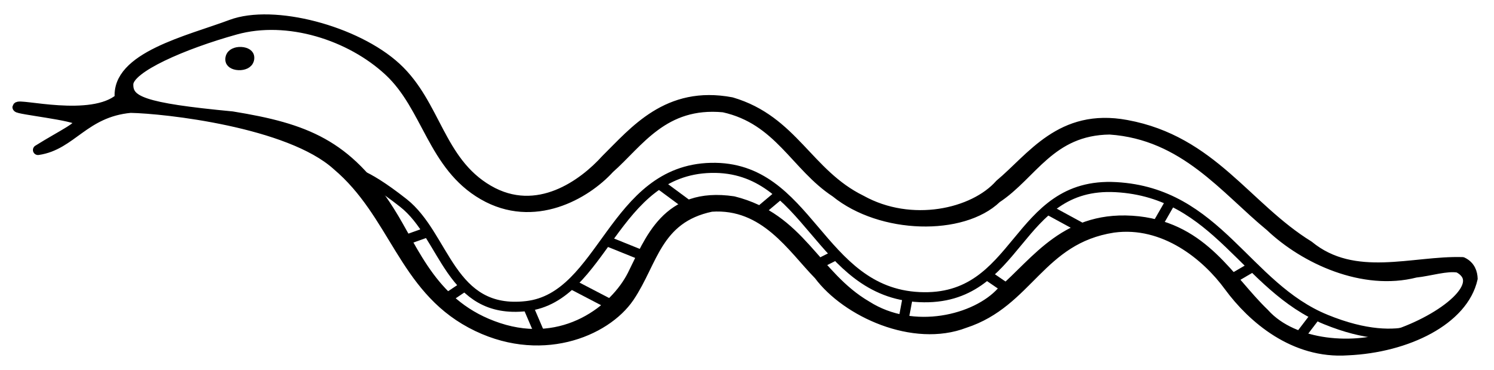  18 Push Ups | 35 Second Plank | 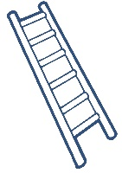  18 Burpees | 40 Star Jumps
18 Lunges | 30 Sit Ups | 16 Leg  Raises | 20 Push Ups | 2 Sit Ups
10 shuttle runs | 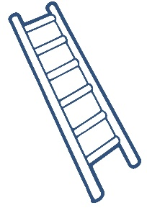  20 Tricep Dips | 35 Second Wall Sit | 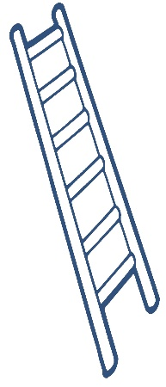  16 Burpees | 20 Leg Raises
30  Lunges | 20 Leg  Raises | 15 Burpees | 15 Tricep  Dips | 20 Squats
18 Hip Raises | 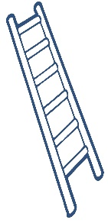  9 Shuttle Runs | 18 Push Ups | 25 Sit Ups | 18 Star Jumps
START | 30 Second Wall Sit | 35 Second Plank | 40 High Knees | 15 Squats
LEVEL 3 – Gold
- Player with least letters in their name goes first
- Climb UP the ladders and slide DOWN the snakes
- Use the QR code below to roll a dice online
- Write your initials in the box you are given to keep your place
- If you land on a ladder or snake you must perform the exercise BEFORE moving up or down
- If you roll a 6 you get an extra turn
- If your final roll takes you past the finish, you stay where you are and perform that exercise again
- The winner picks a forfeit from the board for the losing players

DICE QR CODE (Scan with snapchat)

