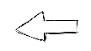  FINISH | 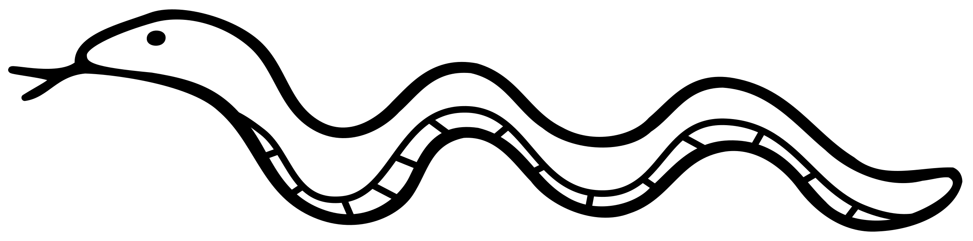  12 Push Ups | 25 Second Plank | 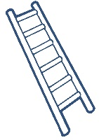  12 Burpees | 30 Star Jumps
12 Lunges | 20 Sit Ups | 10 Leg  Raises | 10 Push Ups | 20 Sit Ups
7 shuttle runs | 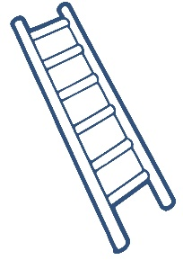  16 Tricep Dips | 25 Second Wall Sit | 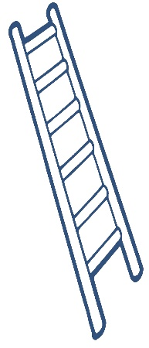  12 Burpees | 16 Leg Raises
20  Lunges | 10 Leg  Raises | 10 Burpees | 10 Tricep  Dips | 16 Squats
16 Hip Raises | 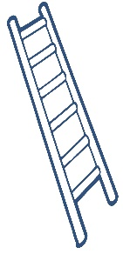  6 Shuttle Runs | 10 Push Ups | 20 Sit Ups | 10 Star Jumps
START | 25 Second Wall Sit | 20 Second Plank | 30 High Knees | 10 Squats
LEVEL 2 – Silver
- Player with least letters in their name goes first
- Climb UP the ladders and slide DOWN the snakes
- Use the QR code below to roll a dice online
- Write your initials in the box you are given to keep your place
- If you land on a ladder or snake you must perform the exercise BEFORE moving up or down
- If you roll a 6 you get an extra turn
- If your final roll takes you past the finish, you stay where you are and perform that exercise again
- The winner picks a forfeit from the board for the losing players

DICE QR CODE (Scan with snapchat)

